ELE 882 Assignment 3

Question 1.

Removing noise from additive:

Applying a Gaussian filter to additive noise allows us to clear up most of the image. The process can be seen below:

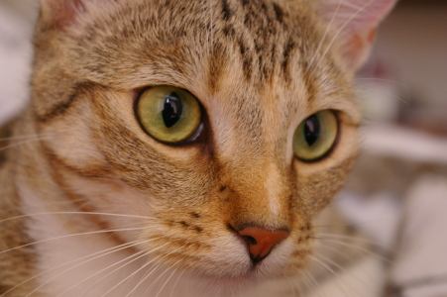

Figure 1: Original Image

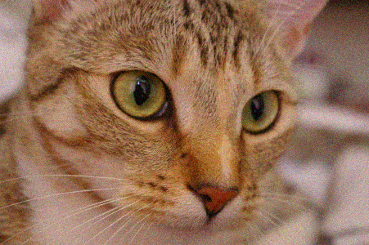

Figure 2: Additive noise on original image



Figure 3: Removal of additive noise using a 0.7 gaussian blur filter

From the noisy image, the noise is spread as a gaussian distribution, therefore by using the gaussian filter, the noise is blurred allowing the noise to dissipate making the image looking more like the original image seen in figure 1.